Business Logic Processing

🧾 What Is Business Logic Processing?
# Source: AI Source: Provided by: [Data Path: Persons Table -> ID Column: 1, Name_En Column: Motasem Essam] -> From: [ChatGPT] on [2/12/2026]
Business logic processing is the part of the system where rules, calculations, and decisions are applied to data to produce meaningful results.
👉 It is the brain of the application.

✅ Simple Definition:
# Source: AI Source: Provided by: [Data Path: Persons Table -> ID Column: 1, Name_En Column: Motasem Essam] -> From: [ChatGPT] on [2/12/2026]
Business logic is the set of rules and operations that define how data is processed in an application.

🧠 Real-Life Analogy:
# Source: AI Source: Provided by: [Data Path: Persons Table -> ID Column: 1, Name_En Column: Motasem Essam] -> From: [ChatGPT] on [2/12/2026]
Think of it like a bank system 🏦:
● You request to withdraw money
● System checks:
- Do you have enough balance?
- Is your account active?
👉 Based on rules → approve or reject

🔁 How Business Logic Works
# Source: AI Source: Provided by: [Data Path: Persons Table -> ID Column: 1, Name_En Column: Motasem Essam] -> From: [ChatGPT] on [2/12/2026]
- 📥 Data is received (input)
- 🔍 Data is validated & sanitized
- 🧠 Business rules are applied
- ⚙️ Calculations or decisions happen
- 📤 Result is returned or stored

📊 Examples of Business Logic

🔹 1. Authentication
# Source: AI Source: Provided by: [Data Path: Persons Table -> ID Column: 1, Name_En Column: Motasem Essam] -> From: [ChatGPT] on [2/12/2026]
👉 Check login credentials
- If correct → allow access
- If wrong → reject

🔹 2. Calculations
# Source: AI Source: Provided by: [Data Path: Persons Table -> ID Column: 1, Name_En Column: Motasem Essam] -> From: [ChatGPT] on [2/12/2026]
👉 Example:
- Total price = quantity × price
- Apply tax or discount

🔹 3. Conditions & Rules
# Source: AI Source: Provided by: [Data Path: Persons Table -> ID Column: 1, Name_En Column: Motasem Essam] -> From: [ChatGPT] on [2/12/2026]
👉 Example:
- Age ≥ 18 → allow registration
- Stock > 0 → allow purchase

🔹 4. Workflow Decisions
# Source: AI Source: Provided by: [Data Path: Persons Table -> ID Column: 1, Name_En Column: Motasem Essam] -> From: [ChatGPT] on [2/12/2026]
👉 Example:
- Order placed → process payment → ship item

💻 Simple PHP Example
# Source: AI Source: Provided by: [Data Path: Persons Table -> ID Column: 1, Name_En Column: Motasem Essam] -> From: [ChatGPT] on [2/12/2026]
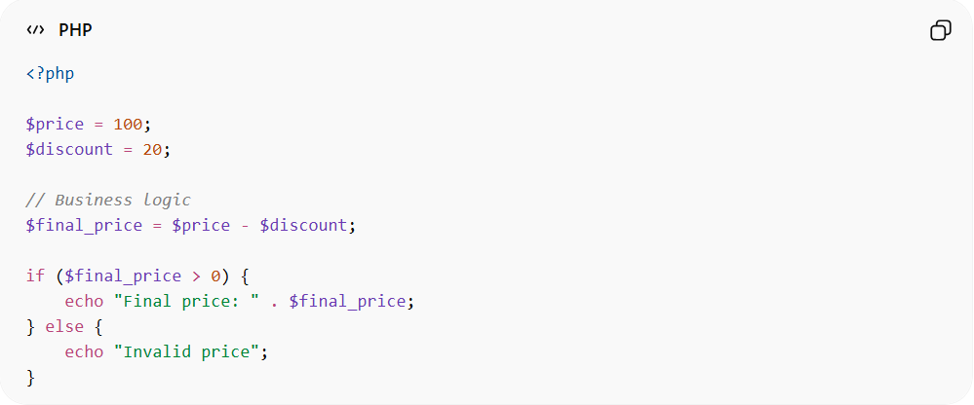
<?php

$price = 100;
$discount = 20;

// Business logic
$final_price = $price - $discount;

if ($final_price > 0) {
echo "Final price: " . $final_price;
} else {
echo "Invalid price";
}
● Applies calculation rule
● Uses condition to validate result
● Produces final output

📦 Example (E-commerce)
# Source: AI Source: Provided by: [Data Path: Persons Table -> ID Column: 1, Name_En Column: Motasem Essam] -> From: [ChatGPT] on [2/12/2026]
Input:
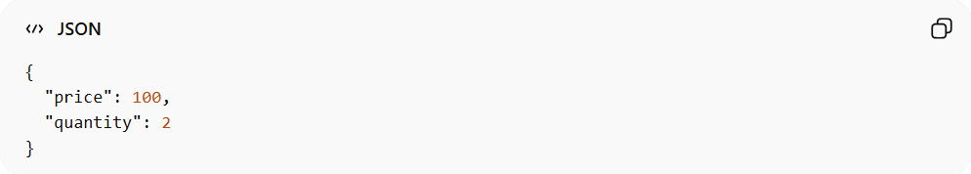
{
"price": 100,
"quantity": 2
}
Processing:
👉 total = price × quantity = 200
Output:
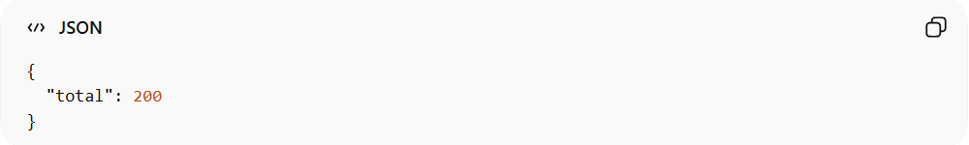
{
"total": 200
}

⚠️ Why Business Logic Is Important
# Source: AI Source: Provided by: [Data Path: Persons Table -> ID Column: 1, Name_En Column: Motasem Essam] -> From: [ChatGPT] on [2/12/2026]
Without it:
❌ System has no rules
❌ Data has no meaning
❌ No decisions can be made
👉 It defines how the system behaves

🔗 Relation to Other Topics
# Source: AI Source: Provided by: [Data Path: Persons Table -> ID Column: 1, Name_En Column: Motasem Essam] -> From: [ChatGPT] on [2/12/2026]
● Input Handling → gets data
● Validation → checks data
● Sanitization → cleans data
● Transformation → prepares data
● Business Logic → uses data to make decisions

⚙️ Best Practices
# Source: AI Source: Provided by: [Data Path: Persons Table -> ID Column: 1, Name_En Column: Motasem Essam] -> From: [ChatGPT] on [2/12/2026]
✅ Keep logic separate from UI
✅ Write clear and simple rules
✅ Avoid mixing logic with HTML
✅ Reuse logic where possible

🎯 Key Idea
# Source: AI Source: Provided by: [Data Path: Persons Table -> ID Column: 1, Name_En Column: Motasem Essam] -> From: [ChatGPT] on [2/12/2026]
👉 Business logic = rules + decisions + calculations
👉 It turns data into meaningful results

🎓 Final Mental Model
# Source: AI Source: Provided by: [Data Path: Persons Table -> ID Column: 1, Name_En Column: Motasem Essam] -> From: [ChatGPT] on [2/12/2026]
● Input → raw data
● Validation → check
● Sanitization → clean
● Transformation → convert
● Business Logic → THINK & decide 🧠
👉 This is where the system becomes “smart”

